ZiFeng Xu (001045590)

**Program Structures & Algorithms**

**Fall 2021**

**Assignment No. 1**

* **Task (List down the tasks performed in the Assignment)**

**Radom Walk**

* **Relationship Conclusion:**
* **$Evidence to support the conclusion:**

1. **Output (Snapshot of Code output in the terminal)**

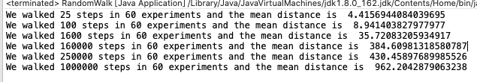

1. **Graphical Representation(Observations from experiments should be tabulated and analyzed by plotting graphs(usually in excel) to arrive on the relationship conclusion)**

These X and Y values ​​are both positive and negative uniformly distributed, so when the number of experiments p is sufficiently large, except for those square terms, everything else is cancelled out.

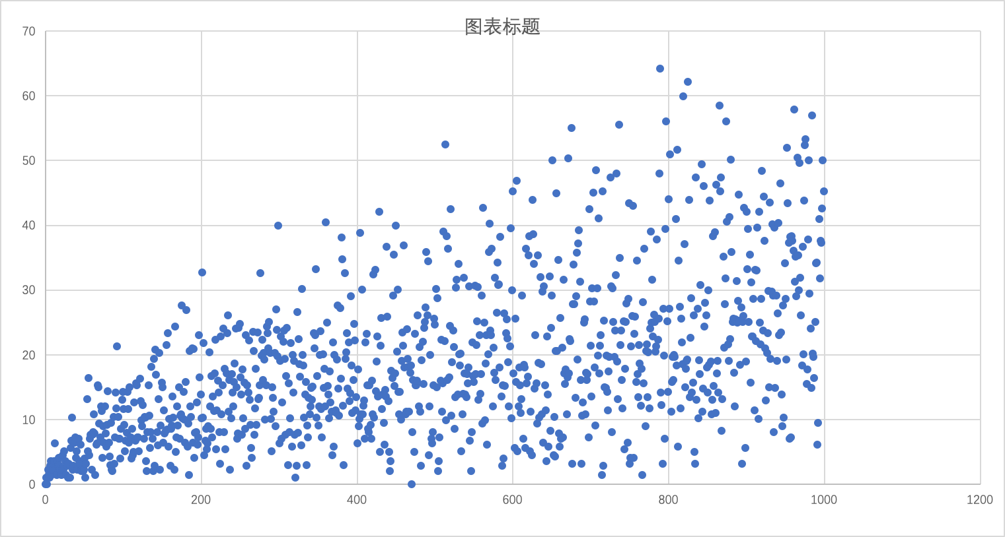

* **Unit tests result:(Snapshot of successful unit test run)**

